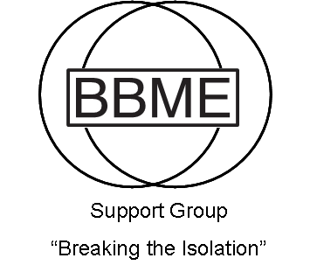
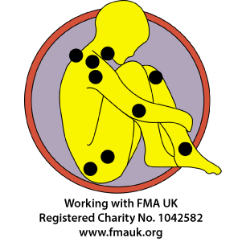
BURY AND BOLTON ME/CFS & FIBROMYALGIA SUPPORT GROUP

Membership / Renewal Form

Registered Charity: 1161356

The Bury and Bolton ME/CFS & Fibromyalgia Support Group membership fee is a minimum annual donation of £10.00 please. Membership runs from April 1st-March 31st each year.
Your donation is important, as it not only helps to run the group, it funds our campaign for awareness and NHS medical provision.
We are working with The Fibromyalgia Association UK (FMA UK).

◻ I am a new member
◻ I am renewing an existing/lapsed membership

Mr/Mrs/Miss/Ms/Other……………….

Surname…………………………………………………………………………………………………

First-Names……………………………………………………………………………………………..

Address………………………………………………………………………………………………….

…………………………………………………………………….Post Code…………………………

Telephone Number (including area code)…………………………………………………………..

E-Mail Address……………………………………………………...................................................

Date of Birth…………………

Do you have ME/CFS?…………………Duration (months/years)…………………………
Do you have Fibromyalgia?…………………Duration (months/years)…………………………

Have you had a positive diagnosis? YES/NO. If YES please give details of who diagnosed you?
Own GP/Hospital/Other………………………….

How did you hear about the Group? …………………………………………

I would like to receive newsletters via: ◻ Email (saves us funds) ◻ Post

I enclose the sum of £………as a donation towards the work of the Bury and Bolton ME/CFS & Fibromyalgia support Group, those affected by the conditions, and their carers.

Payment details overleaf.
You can email the form to BBMEmembership@mesupportgroup.co.uk if paying via internet online banking.

Please consider setting up an annual Standing Order or annual bank payment, for automatic payment in April. This saves us lots of admin, and saves you hassle too!

P.T.O
Online Bank Transfer details:
Sort Code: 20-10-71
Account No: 00902179
Account Name: Bury and Bolton ME/CFS & Fibromyalgia Support Group.

Please email BBMEmembership@mesupportgroup.co.uk with this completed form, payment date and the payment reference you have used so we can identify your payment. Once we have received the monthly bank statement and identified your payment, you will receive an email receipt.

Standing Order: To same account as above, fill in the S.O form below. Please
send to your bank, not us. Once set up only you can cancel it, not us.

PayPal Payment: Use the Paypal.com website or phone app and send your donation to paypal@mesupportgroup.co.uk and include your name and address in the
comments so we know who it’s from please. They will send you a receipt by email.

Cheque: £10 payable to “Bury and Bolton ME/CFS & Fibromyalgia Support
Group” please. You can bring it to a meeting, or send to:
BBME Group, 10 Osmund Ave, Breightmet, Bolton, BL2 6DR

Online bank transfer, standing order and PayPal are easiest for us to administer, but
please let us know if you are having problems. Many thanks for your continued support.

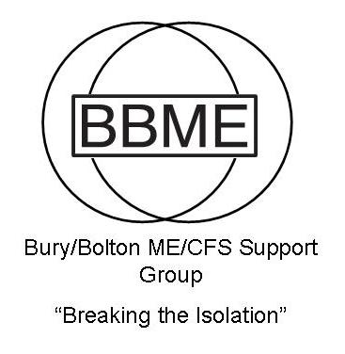
PLEASE RETURN THIS PAGE TO YOUR BANK

Registered Charity 1161356

Standing Order Form
Title:
Forename:
Surname:

Address:

£
Amount to Pay

I hereby instruct my bank to make the above payment to Bury and Bolton ME/CFS Support Group, Account Number 00902179 Sort Code 20-10-71
At Barclays Bank, Bolton BL1 1BU on the ................................ every year.

Name of Account holder:

Bank or Building Society:

Account Number:
Sort Code:

Signature:

Date:

Bury and Bolton ME/CFS & Fibromyalgia Support Group

